
Hub75 synopsys project
Cell Generation & Testbench Comparison

September 24, 2024
Mark Ivey
UTD EECT 6325, VLSI Design

Design Vision Flipflop Output

Inferred memory devices in process
in routine hub75_g_hub_mux4_g_clock_freq200000000_g_color_depth8_g_num_row4_g_num_col4 line 107 in file
'/home/eng/m/mxi240020/6325/projects/hub75/project-1-library_pair/hub75.vhd'.
===============================================================================
| Register Name | Type | Width | Bus | MB | AR | AS | SR | SS | ST |
===============================================================================
| hub_blank_o_reg | Flip-flop | 1 | N | N | N | N | N | N | N |
| hub_latch_o_reg | Flip-flop | 1 | N | N | N | N | N | N | N |
| hub_clk_o_reg | Flip-flop | 1 | N | N | N | N | N | N | N |
| hub_mux_o_reg | Flip-flop | 4 | Y | N | N | N | N | N | N |
| bcd_time_reg | Flip-flop | 3 | Y | N | N | N | N | N | N |
| h_row_reg | Flip-flop | 32 | Y | N | N | N | N | N | N |
| h_col_reg | Flip-flop | 32 | Y | N | N | N | N | N | N |
| disp_timer_reg | Flip-flop | 32 | Y | N | N | N | N | N | N |
| clk_timer_reg | Flip-flop | 32 | Y | N | N | N | N | N | N |
| hub_reg_f_reg | Flip-flop | 1 | N | N | N | N | N | N | N |
| hub_mem_f_reg | Flip-flop | 1 | N | N | N | N | N | N | N |
| hub_out_sm_reg | Flip-flop | 3 | Y | N | N | N | N | N | N |
| hub_piso_r0_reg | Flip-flop | 8 | Y | N | N | N | N | N | N |
| hub_piso_g0_reg | Flip-flop | 8 | Y | N | N | N | N | N | N |
| hub_piso_b0_reg | Flip-flop | 8 | Y | N | N | N | N | N | N |
| hub_r0_o_reg | Flip-flop | 1 | N | N | N | N | N | N | N |
| hub_g0_o_reg | Flip-flop | 1 | N | N | N | N | N | N | N |
| hub_b0_o_reg | Flip-flop | 1 | N | N | N | N | N | N | N |
===============================================================================
Presto compilation completed successfully.
Information: Building the design 'bram_xfer' instantiated from design 'input_mem_g_color_depth8_g_num_row4_g_num_col4' with
the parameters "g_addr_width=4,g_color_depth=8". (HDL-193)
Inferred memory devices in process
in routine bram_xfer_g_addr_width4_g_color_depth8 line 29 in file
'/home/eng/m/mxi240020/6325/projects/hub75/project-1-library_pair/bram_xfer.vhd'.
===============================================================================
| Register Name | Type | Width | Bus | MB | AR | AS | SR | SS | ST |
===============================================================================
| data_out_o_reg | Flip-flop | 8 | Y | N | N | N | N | N | N |
| block_ram_r_reg | Flip-flop | 256 | Y | N | N | N | N | N | N |
===============================================================================

Last Lines of the Cell Report:
registers/s_mem_sipo_r0_reg[7] dff library 7.000000 n
--------------------------------------------------------------------------------
Total 4321 cells 11668.000000

All code can be found here: https://github.com/Mivey/HUB75_Fork
bram_xfer.vhd file
library ieee;
use ieee.std_logic_1164.all;
use ieee.numeric_std.all;
use ieee.math_real.all;

entity bram_xfer is
generic (
g_addr_width : integer := 8;
g_color_depth : integer := 8
);
port (
clk : in std_logic;
en : in std_logic;
we_i : in std_logic;
addr_i : in unsigned(g_addr_width - 1 downto 0);
data_in_i : in std_logic_vector(g_color_depth - 1 downto 0);
data_out_o : out std_logic_vector(g_color_depth - 1 downto 0)
);
end entity bram_xfer;

architecture rtl of bram_xfer is
type t_ram is array(2 ** g_addr_width - 1 downto 0) of std_logic_vector(g_color_depth - 1 downto 0);
signal block_ram_r : t_ram;

begin
ram_operation : process (clk) is
begin
if rising_edge(clk) then
if (en = '1') then
if (we_i = '1') then
block_ram_r (to_integer(addr_i)) <= data_in_i;
data_out_o <= data_in_i;
else
data_out_o <= block_ram_r(to_integer(addr_i));
end if;
end if;
end if;
end process ram_operation;
end architecture rtl;

hub75.vhd file
library ieee;
use ieee.std_logic_1164.all;
use ieee.numeric_std.all;
use ieee.math_real.all;

entity hub75 is
generic (
g_hub_mux : integer := 4;
g_clock_freq : integer := 200_000_000;
g_color_depth : integer := 8;
g_num_row : integer := 4;
g_num_col : integer := 4
);
port (
clk : in std_logic;
hub_mux_o : out unsigned(g_hub_mux - 1 downto 0);
hub_clk_o : out std_logic;
hub_latch_o : out std_logic;
hub_blank_o : out std_logic;
hub_g0_o : out std_logic;
hub_b0_o : out std_logic;
hub_r0_o : out std_logic;
mem_sipo_r0 : in bit_vector(g_color_depth - 1 downto 0);
mem_sipo_g0 : in bit_vector(g_color_depth - 1 downto 0);
mem_sipo_b0 : in bit_vector(g_color_depth - 1 downto 0);
hub_reg_f : out bit;
hub_mem_f : out bit;
mem_hub_f : in bit;
reg_hub_f : in bit
);
end entity hub75;
architecture rtl of hub75 is

type hub_sm is (sm_reset, sm_clk_low, sm_clk_hi, sm_delay, sm_latch_hi);
signal hub_out_sm : hub_sm := sm_reset;
constant hub_clk_tick : integer := (g_clock_freq / 20_000_000) - 1;
type tick_array is array (natural range<>) of integer;
constant disp_tick : tick_array(g_color_depth - 1 downto 0) :=
( 13056 / (2 ** 7) - 1, 13088 / (2 ** 6) - 1, 13088 / (2 ** 5) - 1,
13088 / (2 ** 4) - 1, 13088 / (2 ** 3) - 1, 13088 / (2 ** 2) - 1,
13088 / (2 ** 1) - 1, 13088 / (2 ** 0) – 1 );
signal h_row : integer;
signal h_col : integer;
signal disp_timer : integer;
signal clk_timer : integer;
signal bcd_time : integer range 0 to g_color_depth - 1;
signal hub_piso_r0 : bit_vector(g_color_depth - 1 downto 0);
signal hub_piso_g0 : bit_vector(g_color_depth - 1 downto 0);
signal hub_piso_b0 : bit_vector(g_color_depth - 1 downto 0);

begin

hub_state_machine : process (clk) is
begin
if rising_edge(clk) then
case hub_out_sm is
-----------------------reset----------------------
when sm_reset =>
hub_blank_o <= '1';
hub_latch_o <= '0';
hub_clk_o <= '0';
hub_mux_o <= (others => '1');
bcd_time <= 0;
h_row <= 0;
h_col <= 0;
disp_timer <= disp_tick(0);
clk_timer <= hub_clk_tick;
hub_reg_f <= '0';
hub_mem_f <= '1';
if (mem_hub_f = '1') then
if (reg_hub_f = '1') then -- do I need reg_comp_f?
hub_piso_r0 <= mem_sipo_r0;
hub_piso_g0 <= mem_sipo_g0;
hub_piso_b0 <= mem_sipo_b0;
hub_out_sm <= sm_clk_low;
hub_reg_f <= '1';
elsif (reg_hub_f = '0') then
hub_reg_f <= '0';
hub_out_sm <= sm_reset;
end if;
end if;
----------------------- clk low----------------------
when sm_clk_low =>
hub_r0_o <= to_stdulogic(hub_piso_r0(0));
hub_g0_o <= to_stdulogic(hub_piso_g0(0));
hub_b0_o <= to_stdulogic(hub_piso_b0(0));
disp_timer <= disp_timer - 1;
clk_timer <= clk_timer - 1;
if (clk_timer <= (hub_clk_tick / 2)) then
hub_out_sm <= sm_clk_hi;
hub_clk_o <= '1';
elsif (clk_timer > (hub_clk_tick / 2)) then
hub_out_sm <= sm_clk_low;
hub_reg_f <= '0';
hub_clk_o <= '0';
end if;
----------------------- clk high----------------------
when sm_clk_hi =>
if (clk_timer = 0) then
clk_timer <= hub_clk_tick; -- reset timer
disp_timer <= disp_timer - 1;
hub_clk_o <= '0';
if (h_col < g_num_col - 1) then
hub_out_sm <= sm_clk_low; -- go back and send next bit
h_col <= h_col + 1;
for i in 0 to g_color_depth - 2 loop
hub_piso_r0(i) <= hub_piso_r0(i + 1);
hub_piso_g0(i) <= hub_piso_g0(i + 1);
hub_piso_b0(i) <= hub_piso_b0(i + 1);
end loop;
else -- just sent the MSB, so now wait
hub_out_sm <= sm_delay;
end if;
elsif (clk_timer > 0) then
disp_timer <= disp_timer - 1;
clk_timer <= clk_timer - 1;
hub_out_sm <= sm_clk_hi;
hub_clk_o <= '1';
end if;
----------------------- timer delay----------------------
when sm_delay =>
hub_clk_o <= '0';
if (disp_timer > 0) then
disp_timer <= disp_timer - 1;
hub_out_sm <= sm_delay;
elsif (disp_timer = 0) then
bcd_time <= bcd_time - 1;
disp_timer <= disp_tick(bcd_time - 1);
clk_timer <= 20;
hub_latch_o <= '1';
hub_out_sm <= sm_latch_hi;
hub_piso_r0 <= mem_sipo_r0;
hub_piso_g0 <= mem_sipo_g0;
hub_piso_b0 <= mem_sipo_b0;
if (bcd_time = g_color_depth - 1) then
h_row <= h_row + 1;
hub_blank_o <= '1';
hub_mux_o <= to_unsigned (h_row, hub_mux_o'length);
end if;
end if;
----------------------- latch high----------------------
when sm_latch_hi =>
disp_timer <= disp_timer - 1;
if (clk_timer > 0) then
clk_timer <= clk_timer - 1;
hub_out_sm <= sm_latch_hi;
hub_latch_o <= '1';
elsif (clk_timer = 0) then
if (mem_hub_f = '0') then
hub_out_sm <= sm_reset;
elsif (reg_hub_f = '0') then
hub_out_sm <= sm_latch_hi;
else
hub_out_sm <= sm_clk_low;
hub_reg_f <= '1';
end if;
hub_latch_o <= '0';
hub_blank_o <= '0';
end if;
when others =>
null;
end case;
end if;
end process hub_state_machine;
end architecture rtl;

input_mem.vhd file
library ieee;
use ieee.std_logic_1164.all;
use ieee.numeric_std.all;
use ieee.math_real.all;

entity input_mem is
generic (
g_color_depth : integer := 8;
g_num_row : integer := 8;
g_num_col : integer := 8
);
port (
clk : in std_logic;
reset : in bit;
top_data : in std_logic_vector(24 - 1 downto 0);
top_dv_i : in std_logic;
top_u_l : in std_logic;
top_ack : out std_logic;
mem_out_r0 : out std_logic_vector(g_color_depth - 1 downto 0);
mem_out_g0 : out std_logic_vector(g_color_depth - 1 downto 0);
mem_out_b0 : out std_logic_vector(g_color_depth - 1 downto 0);
addr_i : in unsigned(4 - 1 downto 0);
mem_hub_f : out bit;
hub_mem_f : in bit;
reg_mem_f : in bit;
mem_reg_f : out bit
);
end entity input_mem;

architecture rtl of input_mem is
component bram_xfer
generic (
g_addr_width : integer;
g_color_depth : integer
);
port (
clk : in std_logic;
en : in std_logic;
we_i : in std_logic;
addr_i : in unsigned(g_addr_width - 1 downto 0);
data_in_i : in std_logic_vector(g_color_depth - 1 downto 0);
data_out_o : out std_logic_vector(g_color_depth - 1 downto 0)
);
end component;

type mem_sm is (sm_load, sm_complete, sm_read);
signal simple_mem_sm : mem_sm := sm_complete;
type temp_mem is array (0 to 2) of std_logic_vector(g_color_depth - 1 downto 0);
signal lazy_out : temp_mem;
signal lazy_in : temp_mem;
signal mem_timer : integer;
signal we_i : std_logic;
signal s_addr : unsigned(addr_i'range);
signal mem_full : bit;

begin
RGB_Array : for i in lazy_out'range generate
RGB_Array: bram_xfer
generic map (
g_addr_width => 4,
g_color_depth => g_color_depth
)
port map (
clk => clk,
en => '1',
we_i => we_i,
addr_i => addr_i,
data_in_i => lazy_in(i),
data_out_o => lazy_out(i)
);
end generate;
mem_loader : process (clk) is
begin
---- this process needs to see that both reg and hub are in a state of reset before it releases its own reset.
if rising_edge(clk) then
if (reset = '0') then
simple_mem_sm <= sm_complete;
mem_reg_f <= '0';
mem_hub_f <= '0';
we_i <= '0';
elsif (reset = '1') then
case simple_mem_sm is

when sm_load =>
if (top_dv_i = '0' or (mem_full = '1')) then
top_ack <= '1';
simple_mem_sm <= sm_complete;
we_i <= '0';
mem_timer <= 0;
else
lazy_in(2) <= top_data(3 * g_color_depth - 1 downto 2 * g_color_depth);
lazy_in(1) <= top_data(2 * g_color_depth - 1 downto 1 * g_color_depth);
lazy_in(0) <= top_data(1 * g_color_depth - 1 downto 0 * g_color_depth);
if (s_addr = "111111") then
mem_full <= '1';
else
mem_full <= '0';
end if;
s_addr <= s_addr + 1;
simple_mem_sm <= sm_load;
end if;

when sm_complete =>
if (top_dv_i = '1') then
if (mem_timer < 7) then
simple_mem_sm <= sm_complete;
mem_timer <= mem_timer + 1;
elsif (mem_timer >= 7) then
simple_mem_sm <= sm_load;
mem_full <= '0';
s_addr <= (others => '0');
mem_timer <= 0;
top_ack <= '0';
mem_hub_f <= '0';
mem_reg_f <= '0';
we_i <= '1';
end if;
elsif (top_dv_i = '0') then
mem_timer <= 0;
mem_hub_f <= '1';
mem_reg_f <= '1';
simple_mem_sm <= sm_read;
s_addr <= addr_i;
we_i <= '0';
end if;

when sm_read =>
if (top_dv_i = '0') then
s_addr <= addr_i;
mem_out_r0 <= lazy_out(2);
mem_out_g0 <= lazy_out(1);
mem_out_b0 <= lazy_out(0);
mem_hub_f <= '1';
mem_reg_f <= '1';
elsif (top_dv_i = '1') then
simple_mem_sm <= sm_complete;
mem_hub_f <= '0';
mem_reg_f <= '0';
end if;
when others =>
null;
end case;
end if;
end if;
end process mem_loader;
end architecture rtl;

sipo_reg.vhd file
library ieee;
use ieee.std_logic_1164.all;
use ieee.numeric_std.all;
use ieee.math_real.all;

entity sipo_reg is
generic (
g_color_depth : integer := 8;
g_num_row : integer := 4;
g_num_col : integer := 4
);
port (
clk : in std_logic;
mem_sipo_r0 : out bit_vector(g_color_depth - 1 downto 0);
mem_sipo_g0 : out bit_vector(g_color_depth - 1 downto 0);
mem_sipo_b0 : out bit_vector(g_color_depth - 1 downto 0);
mem_out_r0 : in std_logic_vector(g_color_depth - 1 downto 0);
mem_out_g0 : in std_logic_vector(g_color_depth - 1 downto 0);
mem_out_b0 : in std_logic_vector(g_color_depth - 1 downto 0);
addr_i : out unsigned(4 - 1 downto 0);
reg_hub_f : out bit;
hub_reg_f : in bit;
reg_mem_f : out bit;
mem_reg_f : in bit
);
end entity sipo_reg;

architecture rtl of sipo_reg is
type reg_sm is (sm_stop, sm_load, sm_done);
signal mem_to_reg : reg_sm := sm_stop;
signal reg_col_inc : integer range 0 to g_num_col - 1;
signal reg_row : integer range 0 to g_num_row - 1;
signal reg_cd : integer range 0 to g_color_depth - 1;
signal s_mem_sipo_r0 : bit_vector(g_color_depth - 1 downto 0);
signal s_mem_sipo_g0 : bit_vector(g_color_depth - 1 downto 0);
signal s_mem_sipo_b0 : bit_vector(g_color_depth - 1 downto 0);
signal s_delay : unsigned(1 downto 0);
begin
reg_loader : process (clk) is
begin
if rising_edge(clk) then
case mem_to_reg is
when sm_stop =>
reg_hub_f <= '0';
if (mem_reg_f = '1') then
mem_to_reg <= sm_load;
reg_row <= 0;
reg_cd <= 0;
reg_col_inc <= 0;
addr_i <= (others => '0');
addr_i <= to_unsigned(reg_row, 2) & to_unsigned(reg_col_inc, 2);
elsif (mem_reg_f <= '0') then
mem_to_reg <= sm_stop;
end if;

when sm_load =>
if (mem_reg_f = '1') then
for i in g_color_depth - 2 downto 0 loop
s_mem_sipo_r0(i) <= s_mem_sipo_r0(i + 1);
s_mem_sipo_g0(i) <= s_mem_sipo_g0(i + 1);
s_mem_sipo_b0(i) <= s_mem_sipo_b0(i + 1);
end loop;
s_mem_sipo_r0(7) <= to_bit(mem_out_r0(reg_cd));
s_mem_sipo_g0(7) <= to_bit(mem_out_g0(reg_cd));
s_mem_sipo_b0(7) <= to_bit(mem_out_b0(reg_cd));
addr_i <= to_unsigned(reg_row, 2) & to_unsigned(reg_col_inc, 2);
if (reg_col_inc < g_num_col - 1) then
mem_to_reg <= sm_load;
reg_hub_f <= '0';
reg_col_inc <= reg_col_inc + 1;
elsif (reg_col_inc >= g_num_col - 1) then
mem_to_reg <= sm_done;
s_delay <= "11";
reg_hub_f <= '0';
reg_col_inc <= 0;
if (reg_cd < g_color_depth - 1) then
reg_cd <= reg_cd + 1;
elsif (reg_cd >= g_color_depth - 1) then
reg_cd <= 0;
if (reg_row < g_num_row - 1) then
reg_row <= reg_row + 1;
elsif (reg_row >= g_num_row - 1) then
reg_row <= 0;
end if;
end if;
end if;
elsif (mem_reg_f = '0') then
mem_to_reg <= sm_stop;
reg_hub_f <= '0';
reg_col_inc <= 0;
end if;

when sm_done =>
mem_sipo_r0 <= s_mem_sipo_r0;
mem_sipo_g0 <= s_mem_sipo_g0;
mem_sipo_b0 <= s_mem_sipo_b0;
if (s_delay = "00") then
if (mem_reg_f = '1') then
if (hub_reg_f = '0') then
mem_to_reg <= sm_done;
reg_hub_f <= '1';
elsif (hub_reg_f = '1') then
mem_to_reg <= sm_load;
reg_hub_f <= '0';
end if;
elsif (mem_reg_f = '0') then
mem_to_reg <= sm_stop;
reg_hub_f <= '0';
end if;
else
s_delay <= s_delay - 1;
reg_hub_f <= '1';
end if;

when others =>
null;
end case;
end if;
end process reg_loader;
end architecture rtl;

top.vhd file
library ieee;
use ieee.std_logic_1164.all;
use ieee.numeric_std.all;
use ieee.math_real.all;

entity top is
generic (
g_hub_mux : integer := 4;
g_clock_freq : integer := 200_000_000;
g_color_depth : integer := 8;
g_num_row : integer := 4;
g_num_col : integer := 4
);
port (
clk : in std_logic;
reset : in bit;
top_data : in std_logic_vector(24 - 1 downto 0);
top_dv_i : in std_logic;
top_u_l : in std_logic;
top_ack : out std_logic;
hub_mux_o : out unsigned(g_hub_mux - 1 downto 0);
hub_clk_o : out std_logic;
hub_latch_o : out std_logic;
hub_blank_o : out std_logic;
hub_g0_o : out std_logic;
hub_b0_o : out std_logic;
hub_r0_o : out std_logic
);
end entity top;

architecture rtl of top is
component hub75
generic (
g_hub_mux : integer;
g_clock_freq : integer;
g_color_depth : integer;
g_num_row : integer;
g_num_col : integer
);
port (
clk : in std_logic;
hub_mux_o : out unsigned(g_hub_mux - 1 downto 0);
hub_clk_o : out std_logic;
hub_latch_o : out std_logic;
hub_blank_o : out std_logic;
hub_g0_o : out std_logic;
hub_b0_o : out std_logic;
hub_r0_o : out std_logic;
mem_sipo_r0 : in bit_vector(g_color_depth - 1 downto 0);
mem_sipo_g0 : in bit_vector(g_color_depth - 1 downto 0);
mem_sipo_b0 : in bit_vector(g_color_depth - 1 downto 0);
hub_reg_f : out bit;
hub_mem_f : out bit;
mem_hub_f : in bit;
reg_hub_f : in bit
);
end component;
component sipo_reg
generic (
g_color_depth : integer;
g_num_row : integer;
g_num_col : integer
);
port (
clk : in std_logic;
mem_sipo_r0 : out bit_vector(g_color_depth - 1 downto 0);
mem_sipo_g0 : out bit_vector(g_color_depth - 1 downto 0);
mem_sipo_b0 : out bit_vector(g_color_depth - 1 downto 0);
mem_out_r0 : in std_logic_vector(g_color_depth - 1 downto 0);
mem_out_g0 : in std_logic_vector(g_color_depth - 1 downto 0);
mem_out_b0 : in std_logic_vector(g_color_depth - 1 downto 0);
addr_i : out unsigned(4 - 1 downto 0);
reg_hub_f : out bit;
hub_reg_f : in bit;
reg_mem_f : out bit;
mem_reg_f : in bit
);
end component;
component input_mem
generic (
g_color_depth : integer;
g_num_row : integer;
g_num_col : integer
);
port (
clk : in std_logic;
reset : in bit;
top_data : in std_logic_vector(24 - 1 downto 0);
top_dv_i : in std_logic;
top_u_l : in std_logic;
top_ack : out std_logic;
mem_out_r0 : out std_logic_vector(g_color_depth - 1 downto 0);
mem_out_g0 : out std_logic_vector(g_color_depth - 1 downto 0);
mem_out_b0 : out std_logic_vector(g_color_depth - 1 downto 0);
addr_i : in unsigned(4 - 1 downto 0);
mem_hub_f : out bit;
hub_mem_f : in bit;
reg_mem_f : in bit;
mem_reg_f : out bit
);
end component;
signal mem_sipo_r0 : bit_vector(g_color_depth - 1 downto 0);
signal mem_sipo_g0 : bit_vector(g_color_depth - 1 downto 0);
signal mem_sipo_b0 : bit_vector(g_color_depth - 1 downto 0);
signal reg_hub_f : bit;
signal hub_reg_f : bit;
signal mem_out_r0 : std_logic_vector(g_color_depth - 1 downto 0);
signal mem_out_g0 : std_logic_vector(g_color_depth - 1 downto 0);
signal mem_out_b0 : std_logic_vector(g_color_depth - 1 downto 0);
signal addr_i : unsigned(4 - 1 downto 0);
signal mem_hub_f : bit;
signal hub_mem_f : bit;
signal reg_mem_f : bit;
signal mem_reg_f : bit;
begin
registers: sipo_reg
generic map (
g_color_depth => g_color_depth,
g_num_row => g_num_row,
g_num_col => g_num_col
)
port map (
clk => clk,
mem_sipo_r0 => mem_sipo_r0, mem_sipo_g0 => mem_sipo_g0, mem_sipo_b0 => mem_sipo_b0,
mem_out_r0 => mem_out_r0, mem_out_g0 => mem_out_g0, mem_out_b0 => mem_out_b0,
addr_i => addr_i, reg_hub_f => reg_hub_f, hub_reg_f => hub_reg_f,
reg_mem_f => reg_mem_f, mem_reg_f => mem_reg_f
);
load_n_store: input_mem
generic map (
g_color_depth => g_color_depth,
g_num_row => g_num_row,
g_num_col => g_num_col
)
port map (
clk => clk,
reset => reset,
top_data => top_data,
top_dv_i => top_dv_i,
top_u_l => top_u_l,
top_ack => top_ack,
mem_out_r0 => mem_out_r0,
mem_out_g0 => mem_out_g0,
mem_out_b0 => mem_out_b0,
addr_i => addr_i,
mem_hub_f => mem_hub_f,
hub_mem_f => hub_mem_f,
reg_mem_f => reg_mem_f,
mem_reg_f => mem_reg_f
);
display_out: hub75
generic map (
g_hub_mux => g_hub_mux,
g_clock_freq => g_clock_freq,
g_color_depth => g_color_depth,
g_num_row => g_num_row,
g_num_col => g_num_col
)
port map (
clk => clk,
hub_mux_o => hub_mux_o,
hub_clk_o => hub_clk_o,
hub_latch_o => hub_latch_o,
hub_blank_o => hub_blank_o,
hub_g0_o => hub_g0_o,
hub_b0_o => hub_b0_o,
hub_r0_o => hub_r0_o,
mem_sipo_r0 => mem_sipo_r0,
mem_sipo_g0 => mem_sipo_g0,
mem_sipo_b0 => mem_sipo_b0,
hub_reg_f => hub_reg_f,
hub_mem_f => hub_mem_f,
mem_hub_f => mem_hub_f,
reg_hub_f => reg_hub_f

);
end architecture;

Top_tb.vhd
library ieee;
use ieee.std_logic_1164.all;
use ieee.numeric_std.all;

entity top_tb is
end;

architecture bench of top_tb is
-- Clock period
constant clk_period : time := 5 ns;
-- Generics
constant g_hub_mux : integer := 3;
constant g_clock_freq : integer := 200_000_000;
constant g_color_depth : integer := 8;
constant g_num_row : integer := 4;
constant g_num_col : integer := 8;
constant g_u_row : integer := 2;
constant g_u_col : integer := 3;
constant g_addr_width : integer := 5;
-- Ports
signal clk : std_logic;
signal reset : bit;
signal top_data : std_logic_vector(24 - 1 downto 0);
signal top_dv_i : std_logic;
signal top_u_l : std_logic;
signal top_ack : std_logic;
signal hub_mux_o : unsigned(g_hub_mux - 1 downto 0);
signal hub_clk_o : std_logic;
signal hub_latch_o : std_logic;
signal hub_blank_o : std_logic;
signal hub_g0_o : std_logic;
signal hub_b0_o : std_logic;
signal hub_r0_o : std_logic;
signal finished : boolean := false;
begin
top_inst : entity work.top
generic map (
g_hub_mux => g_hub_mux,
g_clock_freq => g_clock_freq,
g_color_depth => g_color_depth,
g_num_row => g_num_row,
g_num_col => g_num_col,
g_u_row => g_u_row,
g_u_col => g_u_col,
g_addr_width => g_addr_width
)
port map (
clk => clk,
reset => reset,
top_data => top_data,
top_dv_i => top_dv_i,
top_u_l => top_u_l,
top_ack => top_ack,
hub_mux_o => hub_mux_o,
hub_clk_o => hub_clk_o,
hub_latch_o => hub_latch_o,
hub_blank_o => hub_blank_o,
hub_g0_o => hub_g0_o,
hub_b0_o => hub_b0_o,
hub_r0_o => hub_r0_o
);
process is
begin
clk <= '1';
wait for clk_period;
clk <= '0';
wait for clk_period;
if finished then
wait;
end if;

end process;
process is
variable temp : unsigned(3 downto 0);
begin
reset <= '0';
wait for clk_period * 10;
reset <= '1';
wait for clk_period * 2;
top_dv_i <= '1';
top_data <= X"AA55AA";
wait for clk_period * 16;
for i in 0 to 7 loop
temp := to_unsigned(i, 4);
if (temp(0) = '0' ) then
wait for clk_period * 2;
top_data <= X"55AA55";
else
wait for clk_period * 2;
top_data <= X"AA55AA";
end if;
end loop;
wait for clk_period * 2;
top_data <= X"dec0de";
wait for clk_period * 2;
top_data <= X"c0ffee";
for i in 0 to 7 loop
temp := to_unsigned(i, 4);
if (temp(0) = '0' ) then
wait for clk_period * 2;
top_data <= X"55AA55";
else
wait for clk_period * 2;
top_data <= X"AA55AA";
end if;
-- wait for clk_period * 2;
end loop;
wait for clk_period * 2;
top_dv_i <= '0';
wait on top_ack for 1000 * clk_period;
wait for clk_period * 20;
for i in 0 to 31 loop
-- reg_hub_f <= '0';
wait for clk_period * 120880;
end loop;
for i in 0 to 31 loop
wait for 2 * clk_period;
end loop;
wait for 2 * clk_period;
wait for clk_period * 2;
top_dv_i <= '1';
top_data <= X"AA55AA";
wait for clk_period * 16;
for i in 0 to 7 loop
temp := to_unsigned(i, 4);
if (temp(0) = '0' ) then
wait for clk_period * 2;
top_data <= X"55AA55";
else
wait for clk_period * 2;
top_data <= X"AA55AA";
end if;
-- wait for clk_period * 2;
end loop;
wait for clk_period * 2;
top_data <= X"beef1e";
wait for clk_period * 2;
top_data <= X"b0d1e5";
for i in 0 to 7 loop
temp := to_unsigned(i, 4);
if (temp(0) = '1' ) then
wait for clk_period * 2;
top_data <= X"a5a5a5";
else
wait for clk_period * 2;
top_data <= X"969696";
end if;
-- wait for clk_period * 2;
end loop;
wait for clk_period * 2;
top_dv_i <= '0';
wait on top_ack for 1000 * clk_period;
wait for clk_period * 20;
for i in 0 to 31 loop
wait for 2 * clk_period;
end loop;
wait for 2 * clk_period;
finished <= true;
wait for clk_period * 2;
wait;
end process;
end;

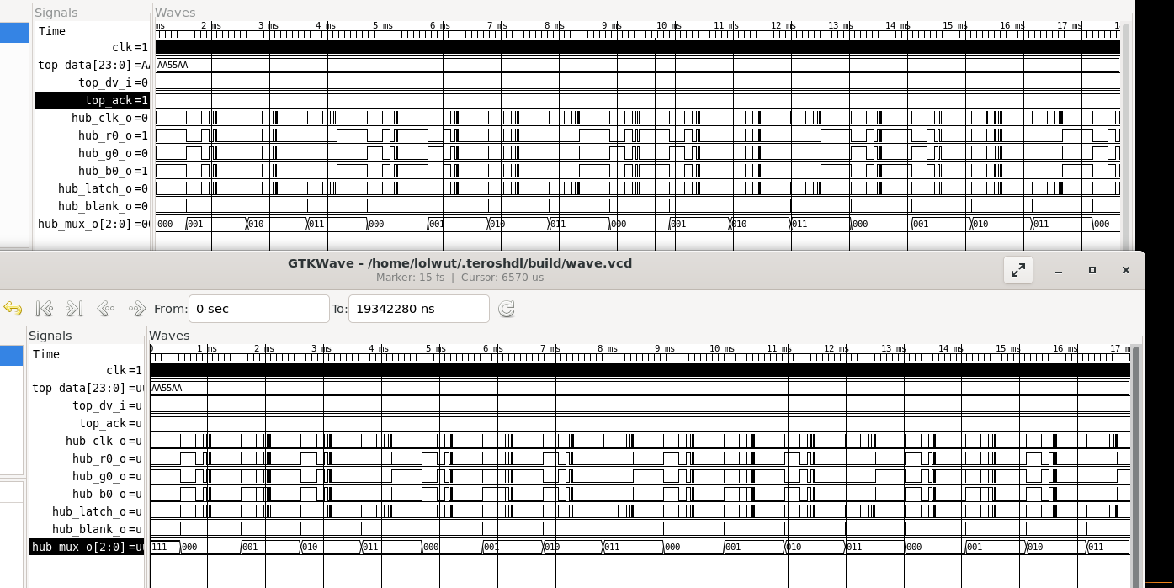
Figure 1: Identical full panel output from behavioral and Synopsys netlist.

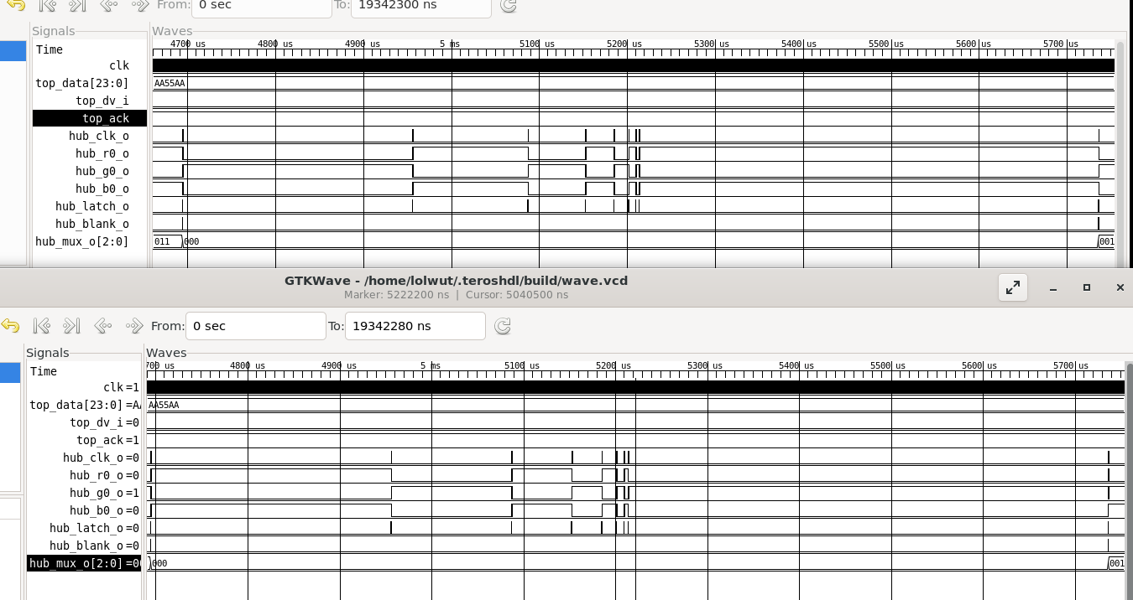
Figure 2: Output of one row of LED's, behavioral vs netlist.
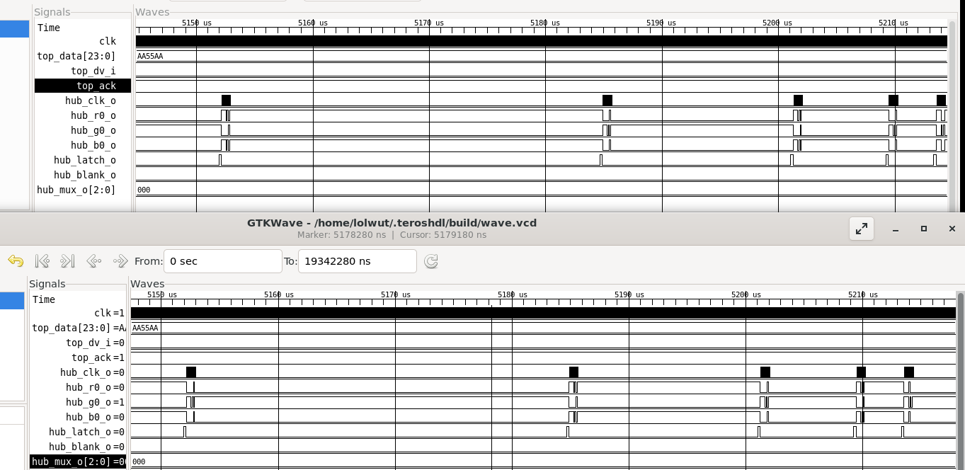
Figure 3: Zoom in on data transfer, Binary Coded Modulation currently being displayed. The wait time between clock and data activity is halved as expected.

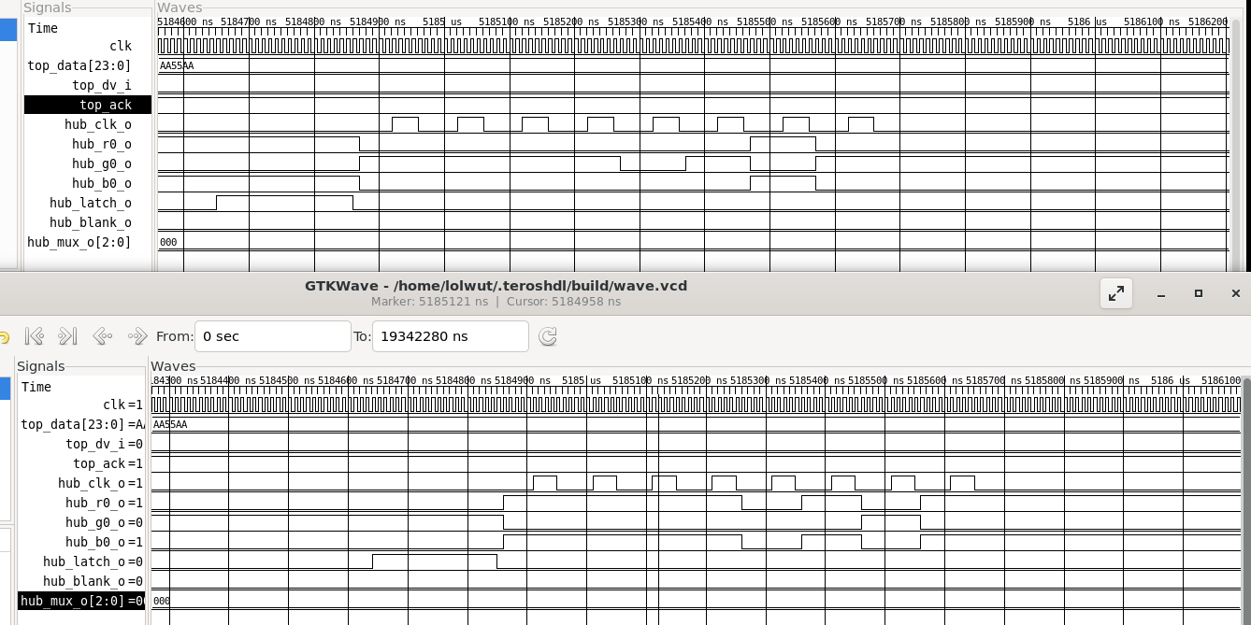
Figure 4: Zoom in on one clock and data transfer.

